**MEETING MINUTES**

**VALLEY ELEMENTARY SCHOOL**

**COMMUNITY COUNCIL**

**110 East State Street, Orderville Utah**

**________________________________________________________**

**Opening:**

The meeting of Valley Elementary School Community Council (“the Council”) was duly called and held on **January 14, 2025** at **11:45 a.m.**

**Present were:**

Emily

Julie Heaton

Hope Adair

Mary Flanagan

1. **Approval of Agenda: Motion- 2nd-** Emily/Julie
2. **Approval of Minutes: Motion- 2nd-** Emily/Julie
3. **Announcements:**
4. **Discussion:**

* Parental Complaints and Student Feelings:
  + The basketball hoops were updated due to parent demand. Unfortunately, the students hate them. School officials respectfully request that parents communicate with their children as well as the school before pushing for changes.
* New Pick-up Route (see attachment):  **Motion- 2nd-** Julie/Hope **- Approved**
* Town Council update on one way for 110 East before and after school:
  + At their last meeting, the Orderville Town Council approved the plan to make 110 E one-way during drop-off and pick-up hours. They also approved the new crosswalk location.

. . .

. . .

. . .

1. **New Business:**

Approval on Behavior Plan/Processes: **Motion- 2nd-** Emily/Julie **- Approved**

Approval on Title 1 Annual Evaluation of School, Parent and Family Engagement

Policy: **Motion- 2nd-** Emily/Julie **- Approved**

1. **Agenda For Next Meeting:**

Approval on New Pick-up Route

Approval on Final Plan for 2024-25 Goals, etc.

**Adjournment:**

Meeting was adjourned at 12:15pm by Julie Heaton. **Motion- 2nd-**

The next general meeting will be at Valley Elementary School **February 11th** at **11:45 a.m.**

Minutes Submitted By: Laura Jennings

Approved By:

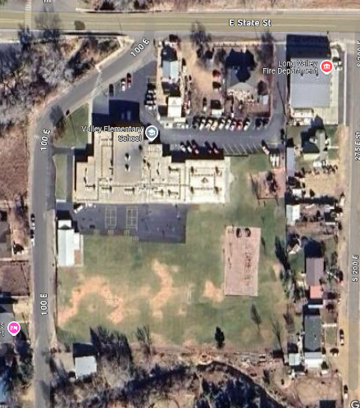

**Parent Pick Up**

-100 East/Main Office

-2 lanes beginning at modular

-Exit onto E State (Right or Left)

**Crosswalk: YELLOW ROUTE**

-Exit Main Office

-Bike Rack

-Exit Building and walk East along building

-Cross at crosswalk North towards E State Street

*Making a Crosswalk on 100 South (town council)

**Bus Pick-Up: BLUE ROUTE**

-North Parking Lot

-Cedar Mtn. & Alton Exit through the East Doors

-Glendale & Mt. Carmel Exit through the North (out from 4th grade)

**South Walking Students**

-Cross at South Crosswalk